🟢 Bandit Level 5 → Level 6
After logging in as bandit5, run:
ls -al
You'll see:
Inhere
The challenge says the password is in a file that is:
- human-readable
- 1033 bytes
- not executable
✅ Find it
Use:
find . -type f -size 1033c ! -executable
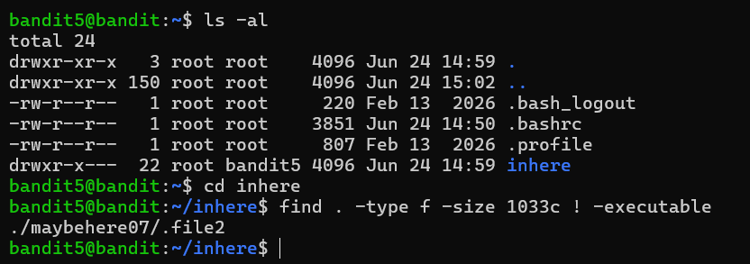
You should get something like:
./maybehere07/.file2
Then read it:
cat ./maybehere07/.file2
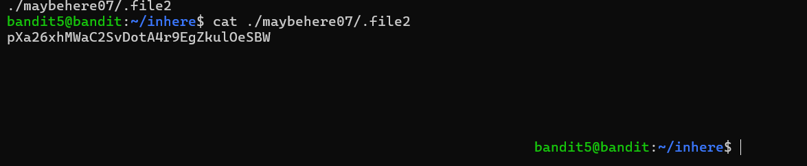
Then 🔑 The output is the password for bandit6. pXa26xhMWaC2SvDotA4r9EgZkulOeSBW
Then exit

